**Lab Practical #02:**

Study of different network devices in detail.

**Practical Assignment #02:**

1. Give difference between below network devices.

* Hub and Switch
* Switch and Router
* Router and Gateway

1. Working of below network devices:
   * Repeater
   * Modem((DSL and ADSL)
   * Hub
   * Bridge
   * Switch
   * Router
   * Gateway

# Hub and Switch

|  |  |  |
| --- | --- | --- |
| No. | Hub | Switch |
| 1 | Works at a Physical layer | Works at a Data-link layer & sometimes Network layer |
| 2 | Broadcasts data to all devices on the network | Routes data to specific devices based on MAC address |
| 3 | Slower speed (Typically 10 Mbps) | Faster speed (1-10 Gbps) |
| 4 | Less secure — sends data to all devices | More secure — sends data only to intended recipient |
| 5 | Obsolete, rarely used, and suitable for small and older networks | Common in modern networks and preferred for professional, scalable networks |
| 6 | Its transmission type is half-duplex (one-way at a t ime)What is Hub in Networking | Types of HUB and its functions | Its transmission type is full-duplex (two-way simultaneously) What is Switch in Networking? || How Switch Device Works? - Radhika Classes |

# Switch and Router

|  |  |  |
| --- | --- | --- |
| No. | Switch | Router |
| 1 | Works at a Data-link layer & sometimes Network layer | Works at Network layer (OSI layer 3) |
| 2 | Connects devices within a network and forwards data based on MAC addresses. | Connects different networks and routes data based on IP addresses. |
| 3 | Cannot provide internet access alone | Can provide internet access |
| 4 | If the destination is not known to switch it will broadcast the frame. | If the destination is not known to router it will drop the packet. |
| 5 | Very fast for internal data transfer | Slower than switch – due to routing, NAT, and firewall processes |
| 6 | Basic – minimal security, mainly controls MAC-level traffic  How does a Switch work? (Animated) | Aziz Ozbek | Strong security with features like a firewall, NAT, packet filtering, and encryption  What is Router in Networking | How Router works and its functions |

# Router and Gateway

|  |  |  |
| --- | --- | --- |
| No. | Router | Gateway |
| 1 | A device that forwards data packets between different networks. | A node that acts as an entry/exit point between different network architectures. |
| 2 | Works mainly at the **Network Layer (Layer 3)**. | Works at **all layers**, depending on protocols used. |
| 3 | Generally **faster**, optimized for packet routing. | May be **slower** due to protocol conversion and deep inspection. |
| 4 | Mostly basic security feature and firewall | Advanced security feature and firewall |
| 5 | For home and office use | Used in large networks such as enterprises |
| 6 | Generated image | What are Gateways in Computer Network? - GeeksforGeeks |

# Working of the below network devices:

1. Switch

* A switch, in the context of computer networking, is a device that connects multiple devices together on a local area network (LAN) and forwards data packets between them based on their destination MAC addresses.
* When it receives a data packet, the switch reads the destination MAC address on the packet and sends it only to the port connected to the destination device that matches the MAC address.
* it acts like a traffic controller, directing data where it needs to go efficiently.

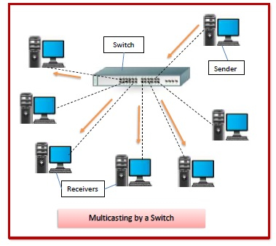

1. Router

* It acts like a traffic controller, directing data where it needs to go efficiently.
* A router acts as a dispatcher, choosing the best route for your information to travel.
* It connects your business to the world, protects information from security threats, and can even decide which computers get priority over others.
* functions: managing traffic between these networks by forwarding data packets to their intended IP addresses, and allowing multiple devices to use the same Internet connection.

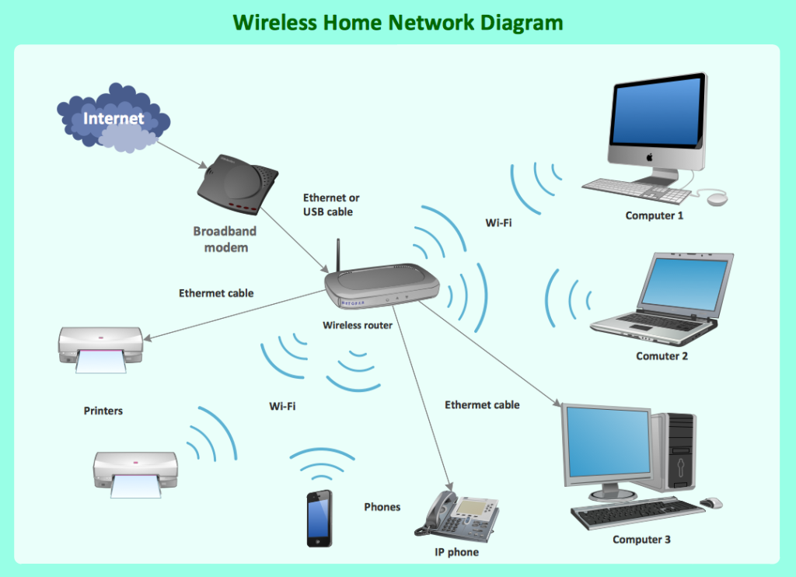

1. Gateway

* The gateway converts information, data or other communications from one protocol or format to another.
* A gateway is a device or node that acts as an entry and exit point for a network, connecting it to other networks that may use different protocols.

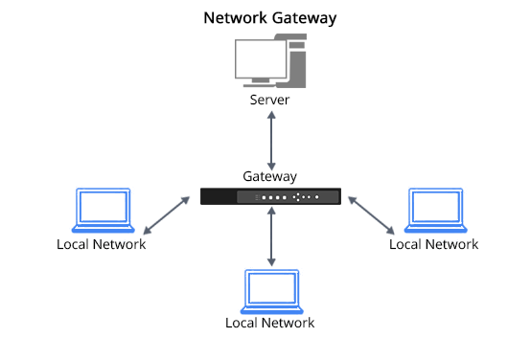

1. Bridge

* Bridges are used to extend the range of the network by connecting two or more physically separated segments.
* Bridges learn which devices are on which segment by building a table of MAC addresses, known as a forwarding table.



1. Hub

* A hub is a device that links multiple computers and devices together.
* It acts as a central point for data transmission, receiving data packets from one device and broadcasting them to all other connected devices.

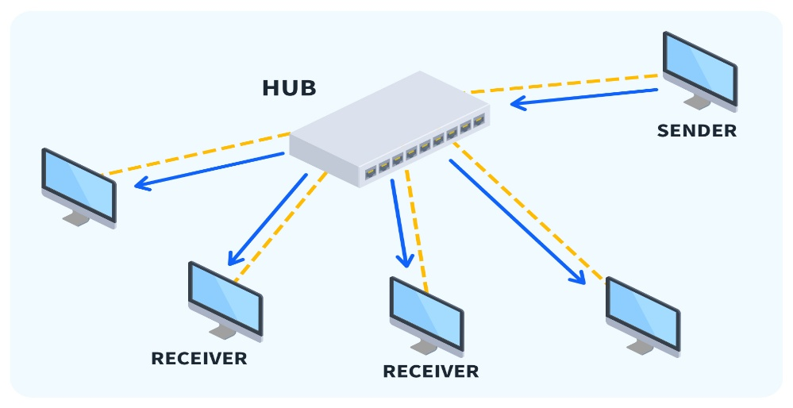

1. Modem((DSL and ADSL)

* Modem is converting digital signals into analog signals for transmission over telephone lines or cable networks, and then converting incoming analog signals back into digital signals for the computer to use.
* ADSL allows you to download data faster than upload and hence it is called asymmetric.
* DSL allows you to upload data faster than download.



1. Repeater

* A repeater in a computer network is a device that amplifies and retransmits incoming signals to extend the reach of a network.
* It is used to increase the network's reach, restore a damaged or weak signal, or provide access to inaccessible nodes.

